09.01
Material Planning
Process Design & AMOS Configuration Document
Purpose
This Process Design document is provided to Key-Users to record their key decisions regarding the AMOS Process design and the required AMOS configuration.
It is updated throughout the Project Definition Phase and used as the baseline for the Final Acceptance prior to Go-Live
Revision
Author, Name | Date | Notes
Daniele Musella | 01.06.2024 | First version

Table of Contents

1. Process Overview & Objectives 3
2. Regulatory References 3
3. Definitions & Glossary 3
4. Process Tasks 3
5. Process Dependencies 8
6. Process Flow 9
7. Process Design Questions 10
8. Data Source Mapping 11
9. Other Software Used 11
10. AMOS Configuration 11
a. Process specific configuration programmes 11
b. Basic Data 11
c. Parameters 11
d. Workflows 12
e. Scheduled Tasks 12
f. API’s & Interfaces 13
11. UAT Guidance 13
12. Annex – Additional Info 14

Process Overview & Objectives
Process General Description:
This Business Process explains provisioning and distribution process and how to maintain enough in stock, both at main station and at outstations, to fulfil material requests.

Main Process Objective (Outputs & Outcomes):
The main objective of Material Planning is to provide the highest possible level of service at the lowest total cost. This applies whether the material planner is tasked with maximizing aircraft and system availability for a scheduled service passenger or cargo airline, or charter operations.
The main goal of is to prevent as many cancellations due to parts shortage as possible by adopting a cost effective inventory provisioning, allocation and management system

Regulatory References
There is no worldwide authority regulation applicable to this process.

Definitions & Glossary
Key-Words | Explanation
EOQ | Economic Order Quantity.
MRO | Maintenance Repair and Overhaul.
N/A | Not applicable.
OEM | Original Equipment Manufacturer.
Part Special | Marks a component with an additional attribute which can be reported by AMOS afterwards.
PO | Purchase order.
RL | Reorder Level
RSPL | Recommended Spares Part List provided by the aircraft/component manufacturer.
US | Unserviceable.
Part Special | Marks a component with an additional attribute which can be reported by AMOS afterwards.

Process Tasks
The main business processes and related AMOS APNs are the following
Station Parts Alerts
Calculate externally the quantity per part number required in each station then upload into Station Parts Alert via Data Transfer XFILE XSPAHEAD/XSPADET.
Activate one Station Parts Alert List per station at a time. Trigger Station to Station transfer with Transfer Orders.
If Material Allocation is active, AutomaticStationSupplyService task in APN 2606 can be set to let AMOS automatically create T-order for all those station/store where the feature Auto Station is active (set Auto Station Supply flag for the selected store in APN 2409)
The lists of parts are always defined at Station/Store level. In he same way, also the “default internal supplier” should be defined at Station/Store level: if no indication is given, AMOS consider as “default internal supplier” the main Station/main Store.
For each part in the list, you must define a Reorder Level and a Ideal Quantity. When the stock level + qty on transfer” at that station/store falls below (or is equal) to Reorder Level, the part number in subject is classified as “to be replenished”.
Parts Consumption Forecast
Parts Consumption Forecast is used to monitor all part requests for Consumables, Expendables and Rotables. Rotables with minimum stock can be managed by setting the safety or minimum stock as "Generic Event - Safety Stock" which will constantly create a demand and reduce the available stock quantity. Initial provisioning according to the recommended spare parts list (RSPL) can also be setup as "Generic Event" to see it in PCF. Note: The RSPL of Airbus/ Boeing T-file, should be used with caution, as several items with a MTBUR of 80000 and more result in a recommended spare purchase. Spare prices and MTBUR should be carefully calculated. APN Rotable Calculator can be used to calculate the required Work In Progress (Repair Loop Quantity) for rotables based on MTBUR, lead time and expected demand.
With the Material Allocation logic, it is possible to hard link part requirements to stock (reservation). If a part is available is calculated based on the Material Allocation Rules. If it is available at a different station and needs transfer it will be indicated. When a part is transferred it is automatically hard linked to the event. The hard link can be broken manually. It is also possible to force the allocation of a part directly on APN 204 Parts Consumption Forecast. The "Force Allocation" button on APN 204 is license controlled (License 2780).
Advanced Reorder Proposal
Used to forecast demand for consumables and expendables based on historic consumption (from 24.6 also for Rotables). The APN calculates the future demand, Economic Reorder Quantity (EOQ), Reorder Level and Safety Stock. To use Advanced Reorder Proposal today calculate Alert Quantity, Reorder Level and Maximum Purchase Quantity (Target Inventory Level) externally and insert into APN59. Activate Reordering to view the Part Number in APN Advanced Reorder Proposal. Do not calculate forecast and reorder quantity.
Alternate Handling: Stock and Requirements are summed up within an Alternate Group. Within an alternate group, first order the preferred part then recalculate. Continue with the second preferred part in the alternate group.
Default Settings for Customer with only a few Fixed Reorder Levels:
If Customer does not have historical consumption to migrate and/or they want to anyhow start with manual reorder level. Please consider the following:
- Manual reorder level, especially if Customer does not migrate history of consumption. When Customer will get familiar, they can think to go through the advanced technique of manual reordering (with their migrated history or AMOS history, after at least 24 months).
  - Manual process. In APN 59, for each PN the Customer wants to follow in ARP (pay attention, only on the leading PN, NOT on its alternates, which will anyhow be followed in ARP), tick “activate reordering”, untick “calculate historical forecast”/“calculate reorder level”/ “calculate safety stock” and to define manually RL, alert level (=50% of RL) and safety stock.
  - Data Transfer: the same can be done via data transfer massively, instead of doing it part-by part, through XPART file.
- Only Default Rule in RPC (Reorder Proposal Configuration). In APN 459:
  - To cancel all the rules (if any) different than the “Default” one (depending on the training snapshot, you may have or may not have other rules than the default one).
  - In the default rule (from AMOS 19.12)
    - Historical forecast tab: Since in APN 59, selected not to use historical forecast, you can also leave the setting of the training snapshot. It is recommended the following setting on Historical Forecast tab as shown below: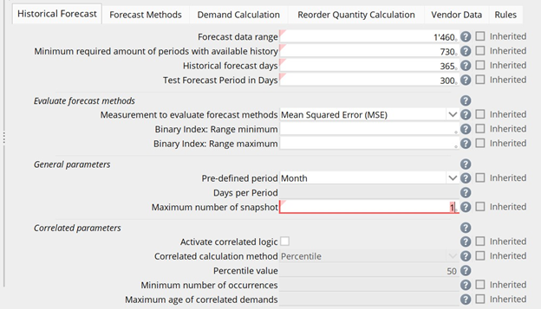
    - Forecast methods: leave ticked all methods.
    - Demand calculation tab: It is recommended the attached setting “demand calculation tab”. Customer can decide to be more conservative (e.g. 3 months of SS instead of 2), but this is the minimum recommended.

    - Reorder Calculation tab: It is recommended the attached setting “reordering calculation tab”. Customer can decide to be more conservative (e.g. 6 months of coverage period instead of 4), but this is the minimum recommended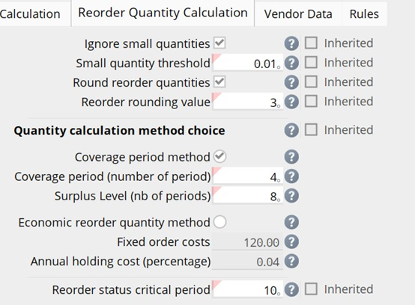
    - Vendor data tab: It is recommended the attached setting “vendor data tab”. In order to fruitfully use that setting, it is important that the Customer defines price book for the different PN. Otherwise, the priority rule will take in consideration the default lead-time set in “demand calculation tab” (here 30 days).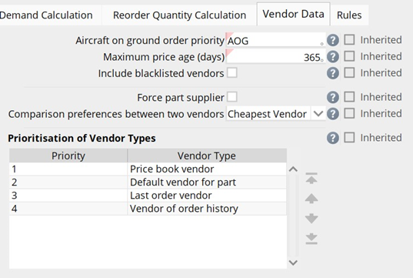
    - Rule tab: In the default rule there should not be any rule. If there is, remove it.
As soon as the Customer will get familiar with this tool and, at least 1 year of history is available, it is strongly recommended to enhance the planning accuracy through the two following settings:
- On APN 59: tick “calculate historical forecast”/”calculate reorder level”/”calculate safety stock”.
- On APN 459: to create the attached exclusion rule (with highest priority than the default rule, which will be used as fall-back strategy). This is meant to exclude from the total forecast (historical + planned) the planned part inside the history, which otherwise will be counted twice as per setting “add the value of historical forecast to the planned consumption quantity” in the “demand calculation” tab.
Final step, after 2-3 years of practice and history, in APN 459
- To add other rules in “group settings” tab, according to specific context (for example: to group PN with high/low consumption and/or high/low lead time and/or high/low price and so on).
- To activate correlation logic in “historical forecast tab” (# of aircraft in the last 48 months *2; maximum age of correlated demands=1460 days; calculation type: “Mean” or Percentile 50 (or 60-75 if you want to be more conservative). In this way:
  - In case you have many years of history in AMOS, you do not take all AMOS history, which can lead you to forecast an average which is too low compared to last 4 years (because of ageing the correlation between finding and original document will increase over the year)
  - The period of 48 months=1.460 days and minimum occurrence =2 were chosen considering the interval of a C-check ( around 24 months), in order to be sure that T/Cs occurring only in C-check should have occurred in both last two events. In fact, if minimum occurrence was highest than 2, no correlation logic would be calculated for T/C occurring during C-check . On the other hands, if minimum number of occurrence is left blank, this is meaning that even with one single occurrence AMOS will calculate the correlation: and, for a T/C whose occurrence is only 1 and in that occurrence there was a findings, this will lead to forecast a 100% of probability of occurrence for the correlated event the next time when the original document is performed
- To add other rules in exclusion settings, if needed (e.g.: to exclude from history phased out aircraft if no other same aircraft type replaced them; to exclude Service Bulletins from the PCF if the Customer manages them in a different way).
Material Allocation
By taking advantage of a customization set of rules AMOS can pre-allocate ordered parts and parts in stock for planned maintenance events.
AMOS checks the stock in the system for each part request and applies the defined rules to determine what part of the stock is available for the selected part requests. If more than one Serial number/Batch is available AMOS applies a prioritization based on pre-defined priority rules. The resulting part on stock will be soft linked with the part request. The recalculation of the allocation is done whenever the part requests, parts on stock or parts on order for a Part number change by a daemon. Parts can be excluded from reordering with the special NO_PRU if Parameter 1556 is active. A soft link can be performed into a hard link manually or automatically based on the settings in Parameter 1704.
- Material Availability. Defines the condition that have to be fulfilled so that a given rotable or consumable batch is available for a given part request. If one of the rules returns true, then the parts can fulfill the part request. A Default Rule exists and it is a good starting point for all customers, that can be customized according to customer’s need.
- Order Availability. Defines the condition that have to be fulfilled so that a given order detail is available for a given part request. If one of the rules returns true, then the parts that will be received on the order detail can fulfill the part request. The default rule here simply consider all orders as “available”. It is recommended to customize it according to customer’s need
- Allocation Priority. Among the available parts and orders defined as available as per “Material Availability” and Order Availability rules, the system automatically select the best parts to fulfill the part request. To make this happen, the administrator has to create appropriate scenario and priorities for each scenario, depending on the organization of his company: Part Station, Expiry date, Remaining quantity in the batch, etc. You can define as many criteria as you need.

- Material Allocation - Activation
It is recommended to activate the material allocation logic in AMOS by using the default rules currently available, but customer have the ability to improve the default rule based on his internal needs. To activate the material allocation logic, you have to set Parameter 1662 to Y (String) and 1 (Integer). You can do this configuration from APN 2629 – Logistics Configuration
- Store Bypass Behavior
The Store Bypass behavior defines the process if a Part Request is marked as externally provisioned. If it is set to Y as soon as the part request is marked as externally provisioned it is closed and disappears from parts consumption forecast. In order to reopen it, it has to be re-created. If the behavior is set to N, the part request will remain in parts consumption forecast with a blue icon. It must be received in the store and pickslipped to finally close the part request. The behavior is defined in Parameter 1565.

- Part Request for Orders
With AMOS 12.0 also Orders can create Part Requests which is defined in Parameter 1662 Float 1.00. Define in Logistics Administration "Enable Default Part Condition" which default Part Condition should be used otherwise the condition in the order will be used for the Material Allocation calculation. Set Exclude in PCF in order not to show the order part request in Parts Consumption Forecast. We recommend in AMOS 12.0 only to show T, V and D order in Parts Consumption Forecast and exclude all other Outgoing Orders (X, PX, PU, LU, YU, CU, O, RU) which usually contain unserviceable units. These types of orders should continue to be managed in Repair Administration.

- Parts Consumption Forecast: Issue Transfer Date
The Issue Transfer Date indicates at which date a transfer has to be issued in order to have the required part at the planned station in time. The lead time required to determine this date is taken from Material Flow Tracking part request update checks all available routes for the ones where the start point is at the main supplier station (system parameter 841) and the end point at the planned station of the part request’s maintenance event. The total estimated time of the fastest route is then taken for the calculation. The calculation is only triggered if the part request’s quantity status is either ‘Transfer Required’ or ‘In Transfer’, in order to optimize the part request update’s performance.
If a route has been found, the instant info of the Issue Transfer column provides a link to the chosen route to show its details. If the latest date to issue the transfer has been missed, the background of the date turns red. The tool tip of the column (hover over the table cell to activate it) also shows the amount of days the transfer is being late.
Note: This feature is deactivated by default.

Process Dependencies

INPUT | CONCURRENT | OUTPUT
- Inventory metrics.  - Manual material allocation.  - Manual order allocation.  - Material availability rules.  - Order availability rules.  - Part supplier contracts.  - Priority rule engine.  - Reliability data.  - RP  - RSPL  - Vendor data. | - 04.04 Approval Control – to monitor the approval of the order issued. | - 09.07 - Outstations & MRO’s  - 10.04 - Part Request Fulfilment (Material Flow Tracking)  - Material/Orders automatically allocated to events.  - Streamlined order creation process by automatically predict quantity to be purchased based on planning definition.  - Visibility on material needs.

Process Flow
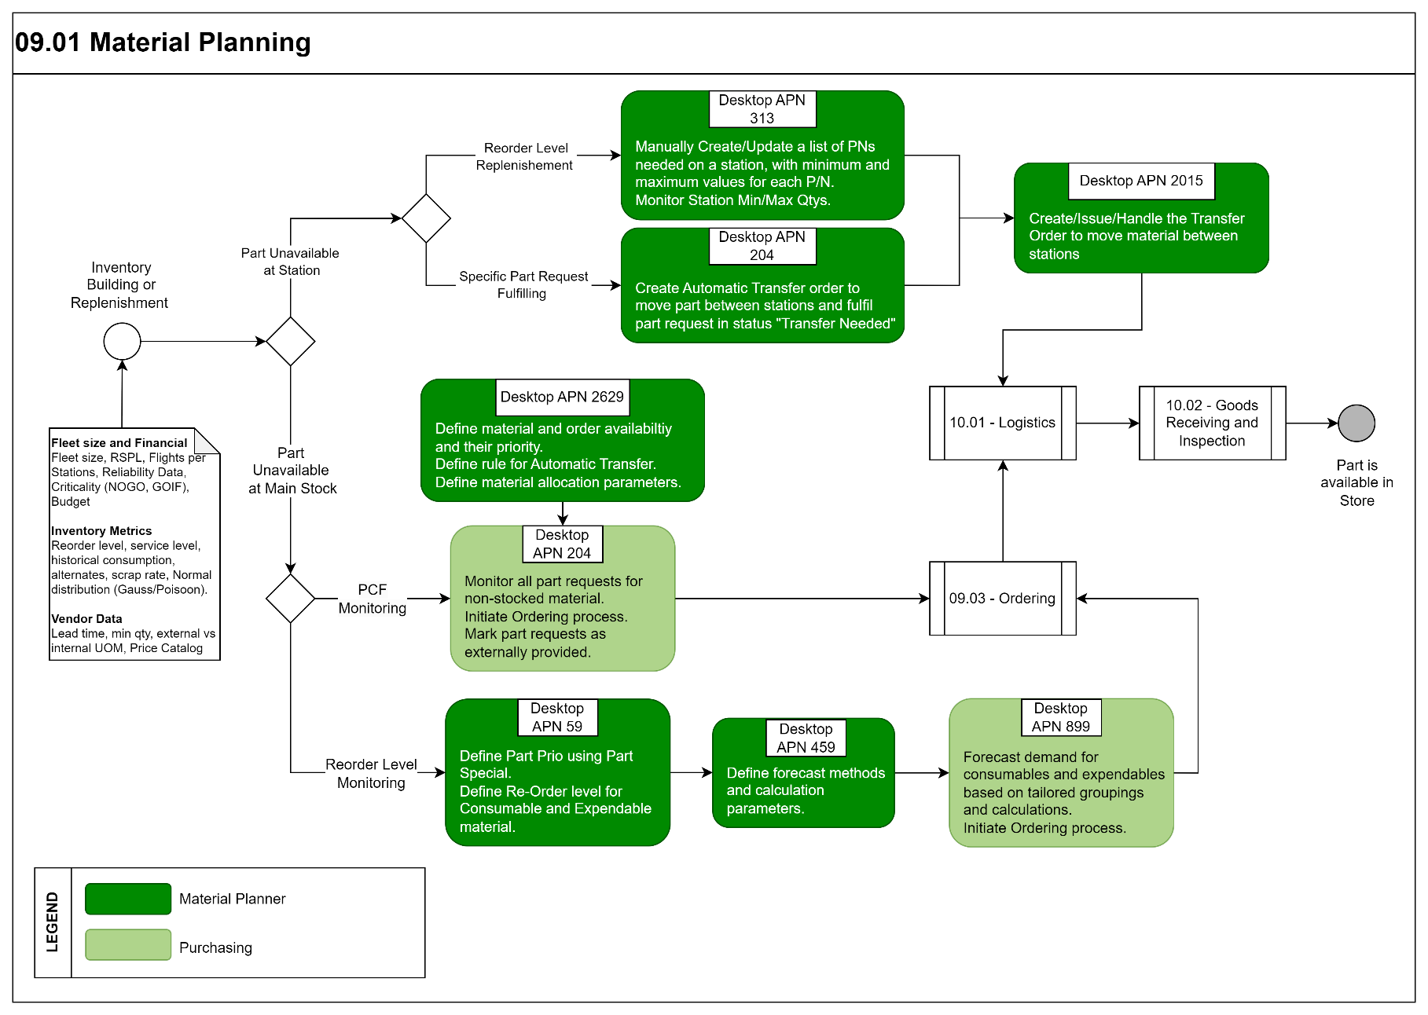

Process Design Questions
# | Question | Answer
1 | Who performs Material Planning?
2 | Who is planning material for the outstations?
3 | Who is responsible to define your reorder level?
4 | Do you use OEM data (RSPL)?
5 | Do you use Reliability Data?
6 | Do you use Vendor Data?
7 | How do you allocate material to an event?
8 | How do you prioritize your material needs?
9 | Do you use consumables support services, e.g. Boeing IMM?

Data Source Mapping
Data Sources | Description | Volume / Manual / Automatic / Static / Dynamic
-/- | -/- | -/-

Other Software Used
Other Software | Used by: | Description
-/- | -/- | -/-

AMOS Configuration

Process specific configuration programmes
AMOS APN | Notes
-/- | -/-

Basic Data
Basic Data Table | Notes
-/- | -/-

Parameters
Parameter Code | Parameter Name | Notes
841 | Default AMOS Main Station | Set the Customer Main Station
1194 | Incl. alternates in Station Parts Alert | Set to yes if alternates should be considered
1581 | Supplier Quantity Check | Only used if AutomaticStationPartSupply Task is setup in Station Parts Alert.
1626 | Use pickslips or transfer orders in Station Parts Alert | Only T-order can be used to move material between stations, string to be set to T
1662 | Part Request Update Setting | Activate Material Allocation Logic, Use the new live update and automatically create part requests for Outgoing Orders.
1732 | Use configurations in Parts Consumption Forecast | The string value defines the accepted part numbers for replacement event part requests.  The integer value activates the automatic post-allocation during part request recalculation.
1704 | Confirm Softlinks | Activate to automatically confirm all soft links to hard links xx days prior to the planned date.
1565 | Store Bypass Behavior | Activate if externally provisioned part requests should be closed and not booked into the system.
1163 | Restriction Level of Parts in Forecast | Not used in new Material Allocation logic. In Old logic used to define if parts on standard/restricted/all parts should be counted into the available quantity.
1896 | Tool Allocation in Parts Consumption Forecast | By activating this parameter, tools on stock or on orders can be allocated to multiple part request.
1417 | Stock Access Matrix | Can be used also in new Material Allocation logic, through the Material Allocation rule wildcard "Has_Stock_Access_Restriction". Location or Part Owner check can also be defined in rule.
1546 | Check Project Number | Can be used also in Material Allocation logic, through the wildcard “Is_Project_Set”
1589 | Maximum Due/Planned Date for Parts Consumption Forecast | Set to 365 to calculate maximum 1 year of future demand
1784 | Specific features for part request percentage
1582 | Issue Date Calculation | Use if Material Flow Tracking is setup for Parts Transfer from Station to Station
1774 | Exclude Non Supplying order types from On order calculation | To be set Y. It concerns both ARP and SPA processes
1877 | ARP Restriction Settings
1674 | Pickslip Request, Get from STORE is mandatory | String: To be set to No

Workflows

Workflow Number | Workflow Name | Workflow Setup Notes
382 | Material allocation, manual linking/unlinking (ID: 382) | Triggers and action if a part is linked/unlinked (hardlink) manually.
73 | Station Parts Alert Workflow (ID: 73) | Triggers an action if the reorder level is reached based on a active Station Parts Alerts list.

Scheduled Tasks

Scheduled Task Reference | Frequency | Notes
PartForecastService | Nightjob | Active to recalculate part requests (based on Parameter 1589)
PartRequestDataCorrectionService | Nightjob | Active to clean up un-used part requests
PickslipEventTransferService | Nightjob | Active to create Part Requests and Generic Events for all Pickslip Requests without Events. Necessary for the Material Allocation to work
AdvancedReorderProposalService | N/A | Not Active: Calculation is currently reworked. Updates the Reorder Data
CalcStoreQtyService | Nightjob | Active to calculate Store Quantities for Station Parts Alert
AutomaticStationSupplyService | Nightjob or, depending on the volumes, up to every 2-3 hours | Scheduler task to check all station stores having the Automated Station Supply flag (in “scheduled” mode) and to automatically create T-order in case of need (If such a store has an active list defined in Station Parts Alert, the list gets checked for parts requiring a re-supply)
AutomaticMaterialTransferTask | Nightjob or, depending on the volumes, up to every 2-3 hours | The scheduler task evaluates all part requests and issues transfer orders if needed., according to rules set in “Automatic Transfer” in APN 2629. We recommend to schedule this task after the Part Forecast Service.
AlternatesGroupCreator | Nightjob/Weekly | Creates Alternate Groups of 2-way Alternates and stores them in a part special

API’s & Interfaces

Reference | Direction | Trigger | Frequency
ExportPartSupply | Export | Material in stock/Price on the parts (Exports part’s price and stock information) | As required
ExportSRTMaterialForecast | Export | Forecast to export | As required

UAT Guidance

1 | Set rules of Material Availability, Order Availability, Allocation Priority, Automatic Transfer in APN 2629 and check the outcome in APN 204
2 | Generate a T-order from PCF through “Transfer Material” button in APN 204 and handle it in APN 2015
3 | Generate a T-order from PCF through “Automatic Transfer” button and handle it in APN 204 and handle it in APN 2015
4 | Create a list of parts for a given station store in APN 313 with Reorder Level and Ideal quantity, then create a stock there and see the AMOS behavior when the stock is below, equal or above Reorder Level
5 | To setup APN 459, to set manual Reorder Level in APN 59 and to check the AMOS behavior for that part number in APN 899
6 | To create a P-order from APN 899 for those parts in status “reorder required”
7 | In APN 899, to check if there are part number with status “NO Vendor found” and fix it
8 | In APN 204, select a part request in status “not available”, and create a P-order for it without linking the part request to the order. Then observes the AMOS behaviour in PCF from the issuing of the order until the receiving of the part
9 | In APN 204, select a part request in status “not available”, and create a P-order for it linking the part request to the order. Then observes the AMOS behaviour in PCF from the issuing of the order until the receiving of the part
10 | To check
11 | Ensure workflows and interfaces are triggered correctly.

Annex – Additional Info
-/-

